**Early Christian Monastery Model-Making**

Round tower

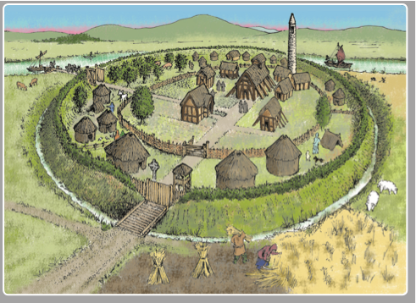

Protective wall

High cross

Refectory/dining room

Oratory/church

Beehive cells

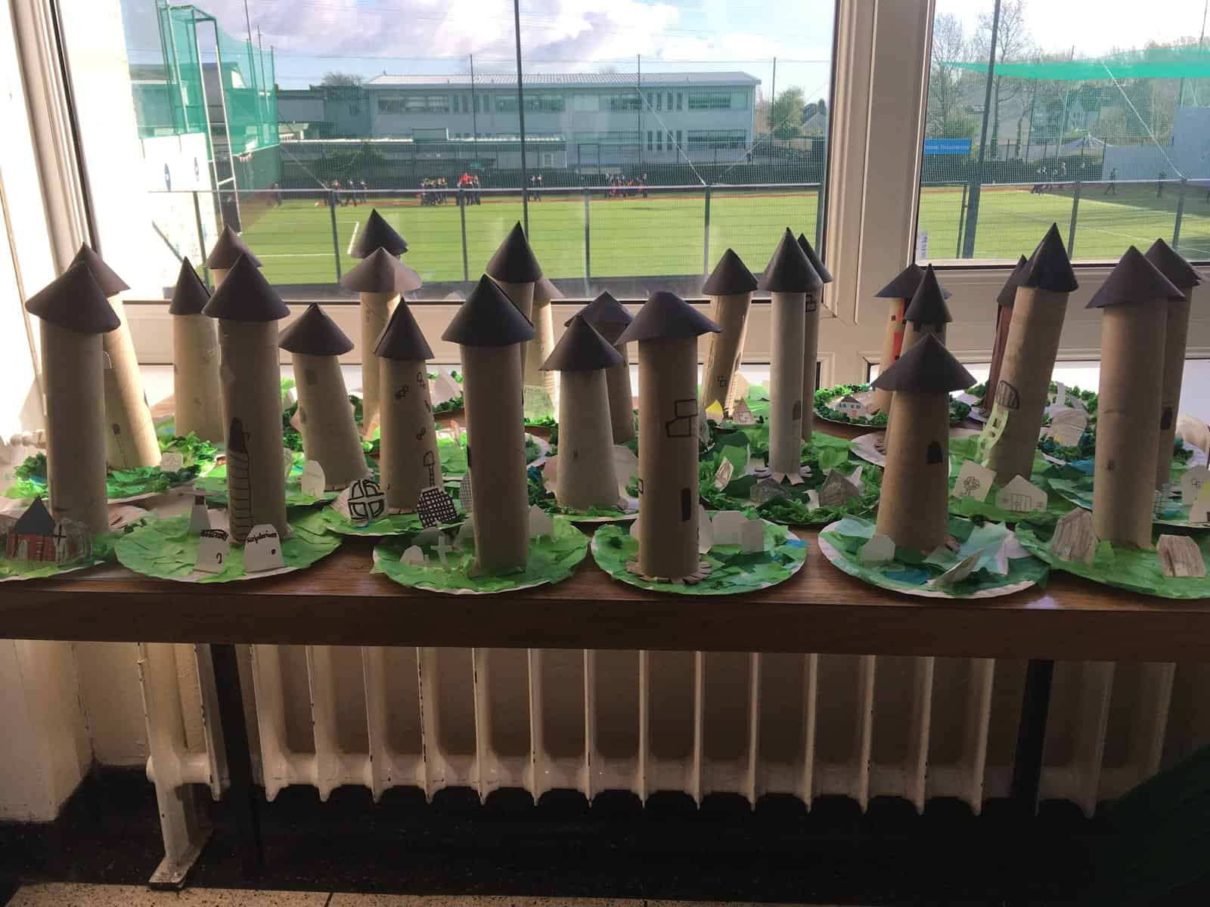Source image 2: [**https://www.belgroveseniorgirls.ie/2019/02/early-christian-ireland-monks-and-monasteries/**](https://www.belgroveseniorgirls.ie/2019/02/early-christian-ireland-monks-and-monasteries/)

**Student instructions:**

1. Study the above diagram of a monastery.
2. You will recreate this monastery using whatever materials you can find – be creative!
3. Your finished model must include:

●  A round tower (this could be made from an empty kitchen roll)

●  Bee-hive cells (huts where the monks slept)

●  An oratory (church)

●  A refectory (dining room)

●  A high cross

●  A protective wall (this could be made from match sticks and cardboard)

1. The base of your model must be at least A4 in size.
2. If you are making this project in class, make a list of what you will need to bring in,

e.g. scissors, glue, tape, cardboard, colouring pencils.

1. Your monastery must be completed by .................................................................................

**Local Historical Buildings**

There are important historical buildings all around us, such as castles, round towers, monasteries, and stately homes.

1. Using Google, or a parent/guardian/teacher to help, name 1 historical building.

|  |
| --- |
|  |

1. Using Google, or with help from a parent/guardian, find some pictures of the historical building.

|  |
| --- |
| Insert images here: |

1. You are going to make a model of this building. What will you need to make the model? E.g. cardboard, glue, paper, scissors, colours, etc.

|  |
| --- |
| List the items here: |

1. Where will you get these items?

|  |
| --- |
|  |

1. Make a model of the local historical building.
2. Your model is due on:

|  |
| --- |
|  |

**Family Tree**

* Please ask your parents/guardians/grandparents to help you fill out the family tree template below.
* For each person try to include the following:

1. Name
2. Date of birth
3. Job

* Family histories can be tricky, you might not be able to fill it all out, that’s ok.

Great- Grandparent